Joey Gomez-Benito

904140064

[jgbenito7@gmail.com](mailto:jgbenito7@gmail.com)

Patrick Killian Jackson

504184347

killianjackson@yahoo.com

Lab 4 File Encryption Design Problem

Specification:

Our goal was to make peer to peer file transfer more secure by encrypting file uploads and downloads. The contents of the file should be encrypted on a byte by byte basis and should prevent network snoopers from viewing the file contents.

In order to separate the code we added from the main functionality of the peer2peer network, we added a new flag ‘-e’ to run the program in encryption mode. We also edited the help section to reflect this new mode and added an entry for ‘make run-e’ in the make file.

In order to easily run our encryption program, a user can simply type ‘make run-e’.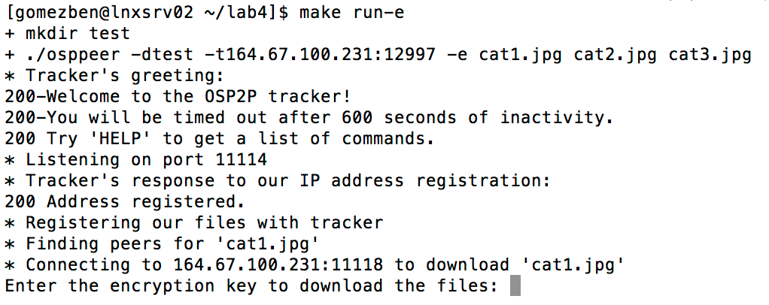

We also added the option for a user to change their password before the program runs. This mode assumes that you are also running the program in encryption mode. We included an option to run the flag ‘-ec’ to run the program in both encryption and change password mode. This brings up a new option to change the password. For security purposes, the old password must be entered beforehand. The default password is ‘pass’.

In order to easily run our encryption program in change password mode, a user can simply type ‘make run-c’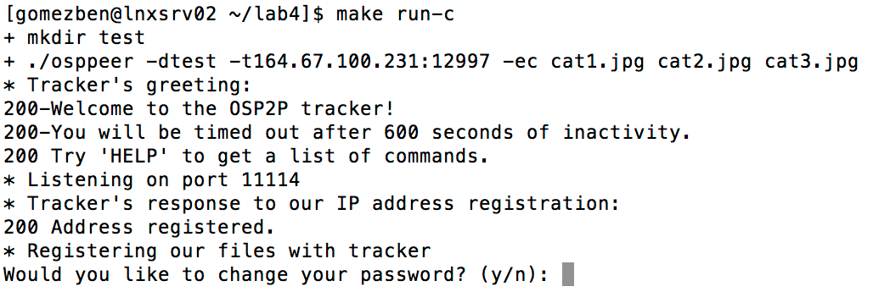

Plan for Implementation:

The first step for implementation was to setup a repository that could be used to push code changes and make working together easy. We made a new github repository and were both added as collaborators. We first had to research file encryption and decide how we were going to encrypt the files. We decided on using at xor bit shift for every byte in the file, because the

same function could be used for both encryption and decryption. When uploading a file, our function would open the file using the filename and create temporary blank file, loop through to

the end of the file, apply ^200 to each character byte, append that byte to the temporary file, and then send the temporary file instead of the original file. When downloading a file, assuming

a unified encryption system, the same method would be used to decrypt the contents of the file.

Once we had this working, we then had to work on asking for a password while trying to download a file from a peer. For the purposes of this project, we did not create a database for storing passwords. If we were developing an actual password system we would have stored user names and passwords in a database and referenced the database for password lookups and changes. We instead have a default password that is restored every time the program runs. Every time a user tries to download a file, he is presented with a prompt to enter the password of the peer that is hosting the file. In order to download the file, the passwords must be correct. If not, the file will not download. We thought this was best to prevent people from trying to decrypt an encrypted file that they are not supposed to have permission to view. Uploads are automatically encrypted while in encryption mode.

Summary of Results:

We managed to successfully implement file encryption and decryption. Our password system is limited, but functional. When we began to implement download decryption and per peer passwords, we realized that parallelizing the downloads no longer made sense because we had to now handle one peer at a time for password checking. The uploads could still be parallelized.

Who did what:

Joey started the implementation by adding a simple passkey global variable and by implementing in the main function a check to see if the passkey was correct. Joey then began implementing an encryption function and a corresponding decryption function. Killian did some additional research on encryption and modified the implementation strategy for the encryption function. Killian finalized the encryption function to use a bitwise xor operation to encrypt files byte by byte. The decryption function was removed as the encryption function served to both

encrypt and decrypt. Killian then added a character array member to task_t to store the peer's password and moved the password check from the main function into the task_download

function. Killian also added the procedure for calling Encrypt(char* filename) into both task_download and task_upload to decrypt and encrypt respectively. Joey then added the implementation allowing the option to change the password, via the -c flag, and also implemented per peer decryption passwords adjusting the previous password check in task_download. Joey then added a flag, -e, to enable encryption mode so the application may run normally or with encryption enabled. We collaborated on the design problem write up.